**Box Collider**

**立方体碰撞器**

[SWITCH TO SCRIPTING](http://docs.unity3d.com/540/Documentation/ScriptReference/BoxCollider.html)

The **Box Collider** is a basic cube-shaped collision primitive.

立方体碰撞器是一种基础的盒型碰撞单元

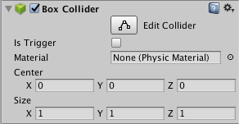

**Properties**

| ***Property:*** | ***Function:*** |
| --- | --- |
| **Is Trigger** | If enabled, this Collider is used for triggering events, and is ignored by the physics engine.  如果开启，碰撞器则用于触发器事件，并且被物理引擎忽略。 |
| **Material** | Reference to the [Physics Material](http://docs.unity3d.com/540/Documentation/Manual/class-PhysicMaterial.html) that determines how this Collider interacts with others.  引用的物理材质决定他和其他碰撞器如何碰撞 |
| **Center** | The position of the Collider in the object’s local space.  碰撞器在对象的局部空间坐标 |
| **Size** | The size of the Collider in the X, Y, Z directions.  碰撞器的X,Y,Z方向的尺寸 |

**Details**

**详情**

Box colliders are obviously useful for anything roughly box-shaped, such as a crate or a chest. However, you can use a thin box as a floor, wall or ramp. The box shape is also a useful element in a compound collider.

立方体碰撞器显然用于任何粗略的盒形，像一个板条箱或者一个柜子。然而，你可以使用一块细盒作为一块地板，走廊或者斜坡。盒子形状也是在复合碰撞器里非常有用的一个元素。